What connects educating girls, climate change and Christian Aid?

Friends of the Earth made a list of the top ten ways to fix a warming planet and there, at number 6, was ‘Educating Girls’. This list is in the book ‘Drawdown’, a copy of which we now have in St John’s library. Based on extensive research, it looks at the top 100 solutions to reduce CO₂ emissions by 2050. Nobel laureate and girls’ education activist, Malala Yousafzai, said “one child, one teacher, one book and one pen can change the world.” Educating girls, ‘Drawdown’ explains, can reduce the harmful effects of climate change in several ways; it reduces population growth, it increases the contribution of women and girls to economic growth and it equips them to face the most dramatic impacts of climate change.

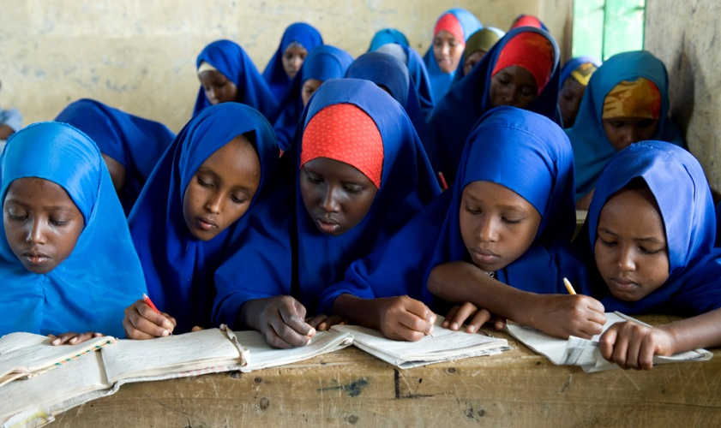
Firstly, educating girls is one of the most powerful ways to combat climate change because it reduces population growth which, in turn, makes a huge contribution to reducing greenhouse gas emissions. As a generalisation, it is the poorest places with the least education available to girls that have the highest rates of population growth. The research shows that if girls get a secondary education, decent health care and control over their own reproduction they have fewer children.

Secondly, educated girls and women are likely to be more empowered at home, at work and in society generally. Their agricultural plots are found to be more productive and their families better nourished. They normally get better wages, are more upwardly mobile and contribute more to economic growth. Their rates of maternal mortality drop, as do the mortality rates of their babies. All these factors make for happier, healthier and more productive people. Educated girls are also less likely to marry as children, or against their will. Child marriage often prevents girls from receiving an education and, conversely, girls with less schooling are more likely to marry early. According to UNICEF, in Nigeria 60% of girls are married before they are 18. Child marriage can trap girls in a cycle of poverty and powerlessness, damaging their health as well as their prospects and those of their children. In many cultures girls are expected to stay at home, run the house and look after younger children, which prevents them from going to school themselves. In sub-Saharan Africa fewer than 1 in 3 girls attends secondary school, and whilst 75% of girls start school only 8% finish their secondary education.
Thirdly, ‘Drawdown’ explains, if they are educated women can be more effective stewards of food, soil, trees and water, even as nature’s cycles are changing in response to global warming. With an education they will have a greater capacity to cope with shocks from natural disasters and extreme weather events. As educated girls grow into educated women they can fuse together inherited, traditional knowledge with new information accessed through the written word, making them better able to cope with new crop diseases, altering seasons and weather patterns, and things like how to improve soil composition.
Next month St John’s will again be supporting Christian Aid week. Christian Aid has a proven track record of supporting the education of women and girls and this year’s campaign will focus in particular on helping communities in Kenya to adapt to climate change. Happily, Kenya has made significant gains in education in recent years with more than 80% of boys and girls now enrolled in primary school, but for secondary school the rate falls to 50% and poverty remains the main reason for low enrolment. If there are financial constraints it is boys who are given priority for higher education.
So how will Christian Aid help? This year’s campaign highlights the story of Faith, and her husband Stephen, who are experiencing Kenya’s worst drought in decades. As a result, they have been unable to grow crops, are experiencing real hunger and have been unable to send their children to school. Christian Aid’s partners in Kenya, ADSE, have a programme to construct sand dams which can store the rainfall, when it comes, so Faith’s community can have more resilience in times of drought. In this way, whilst the rainfall remains irregular, they can continue to grow their crops. Faith says she will “do her best to educate her children so they can be what they want to be when they grow up.” I’m sure St John’s will support her in this hope by helping once again with the Christian Aid house to house collections in May. Incidentally, the Diocese of Sheffield now has a link with the Diocese of Bondo, Kenya and this summer the Bishop of Bondo will visit the UK for the Lambeth Conference. Perhaps we will be able to hear more about life in Kenya when he comes to Sheffield.

Throughout 2020 Christian Aid is asking for prayer for climate justice. Millions of the world’s poorest people are feeling the worst impacts of climate change and experts predict more floods, drought and extreme weather patterns to come. For those living in poverty this means more hunger, conflict and insecurity, and a more uncertain future for us all. If you go to the Christian Aid website you can sign their petition asking the UK Government to deliver a New Deal for Climate Justice. In giving generously of our time and money during Christian Aid week we can both support girl’s education and combat climate change.

Deborah Page

PS: Following last month’s article about flying, if you want to off-set your carbon emissions from flights, try this excellent organisation, Climate Stewards, who both calculate your emissions and offer various off-setting schemes, mostly in developing countries. https://www.climatestewards.org

Sources:
‘Drawdown’, published by Penguin. https://www.drawdown.org/solutions/women-and-girls/educating-girls
Christian Aid. https://www.christianaid.org.uk/campaigns/climate-change/climate-justice-petition

Addendum:
As an addendum to this article, Matthew asked me to mention that one of the greatest inhibitors of girls’ education is the availability of proper lavatories in schools. Our new disabled lavatory in the Parish centre will be twinned with a new lavatory in the developing world. Hopefully this will help!

